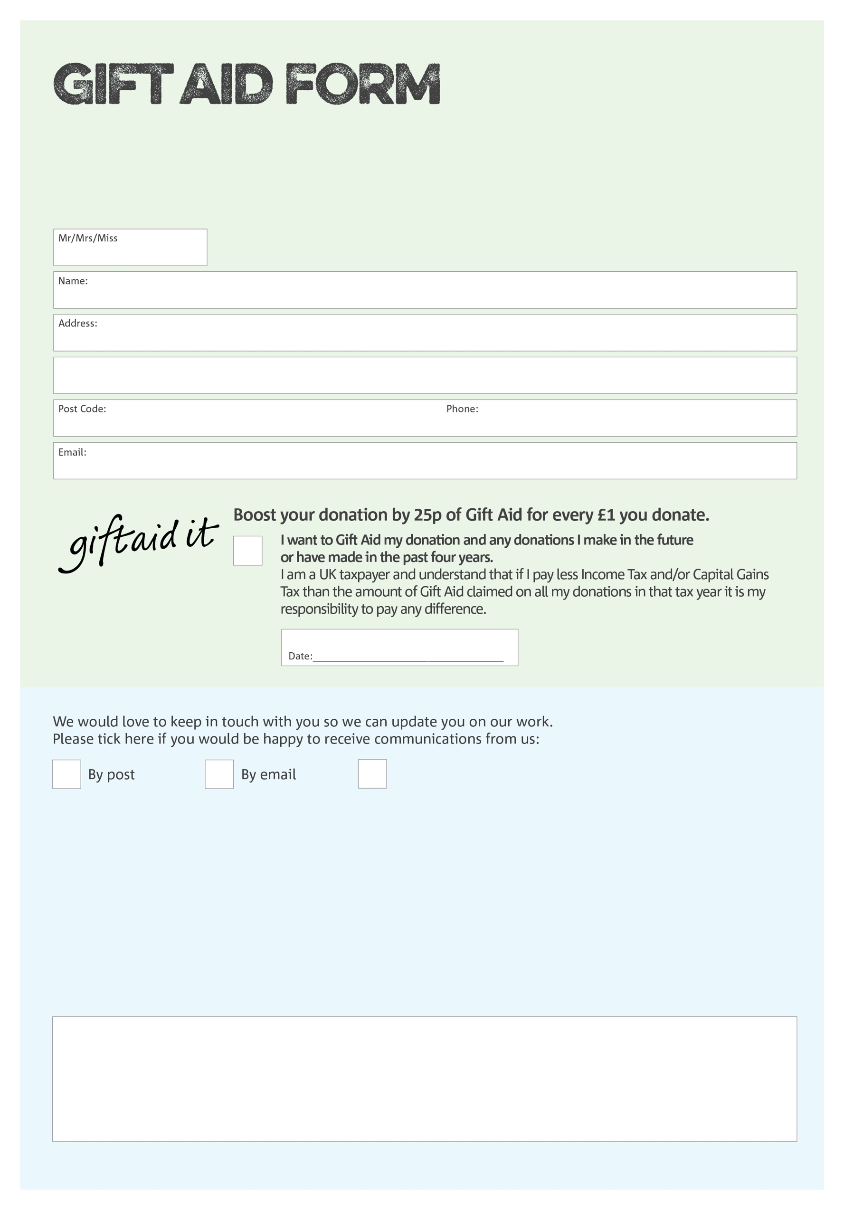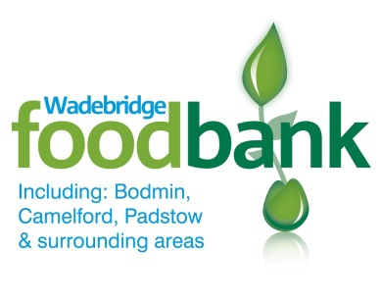

By filling in this form Wadebridge Foodbank will receive an extra 25p for every £1 you give at no extra cost to you. Thank you!

Signature:

I do not wish to receive future communications from Wadebridge Foodbank

You can change your preferences any time by contacting us on 01208 815374 or emailing us at

contact@wadebridgefoodbank.org

We would love to know why you have chosen to donate to Bodmin, Camelford & Wadebridge Foodbank. If you would like to share your motivation let us know below:

**Data protection**

*Wadebridge Foodbank is committed to protecting your privacy and will process your personal data in accordance with current Data Protection legislation. Wadebridge Foodbank collects information to keep in touch with you and supply you with information relating to our work. To unsubscribe from our newsletter, send a message to the email address above with the word unsubscribe in the subject line. A full data privacy statement for financial donors is available from the foodbank on request.*

Charity Number 1166301. Registered in England & Wales