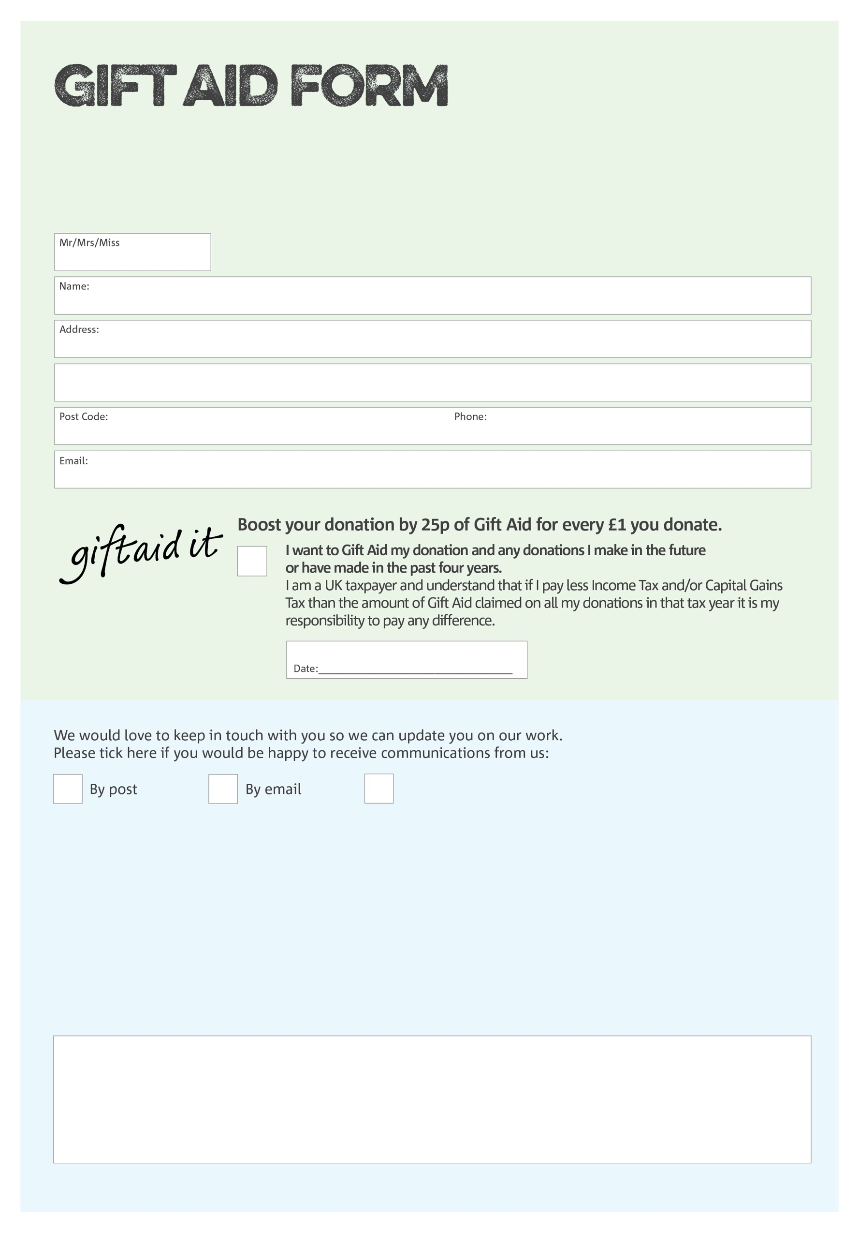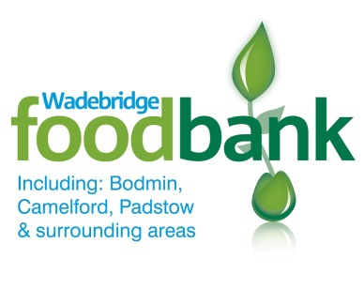

By filling in this form Bodmin, Camelford & Wadebridge Foodbank will receive an extra 25p for every £1 you give at no extra cost to you. Thank you!

If the item(s) donated are sold in excess of £100, please tick to confirm you wish to donate all the money raised to our charity.

Amount donated:

Wadebridge Foodbank & Storehouse Bank Details - **Sort Code:** 30-98-98 **Account Number:** 01663223

**Data protection**

*Wadebridge Foodbank is committed to protecting your privacy and will process your personal data in accordance with current Data Protection legislation. Wadebridge Foodbank collects information to keep in touch with you and supply you with information relating to our work. To unsubscribe from our newsletter, send a message to the email address above with the word unsubscribe in the subject line. A full data privacy statement for financial donors is available from the foodbank on request.*

We would love to know why you have chosen to donate to Bodmin, Camelford & Wadebridge Foodbank. If you would like to share your motivation let us know below:

You can change your preferences any time by contacting us on 01208 815374 or emailing us at

[contact@wadebridgefoodbank.org](mailto:contact@wadebridgefoodbank.org) or writing to us at Wadebridge Foodbank & Storehouse, 4 Eddystone Road, Wadebridge, Cornwall PL27 7AL. Charity number: 1166301 reg. in England/Wales

Signature:

I do not wish to receive future communications from Wadebridge Foodbank

Charity Number 1166301. Registered in England & Wales