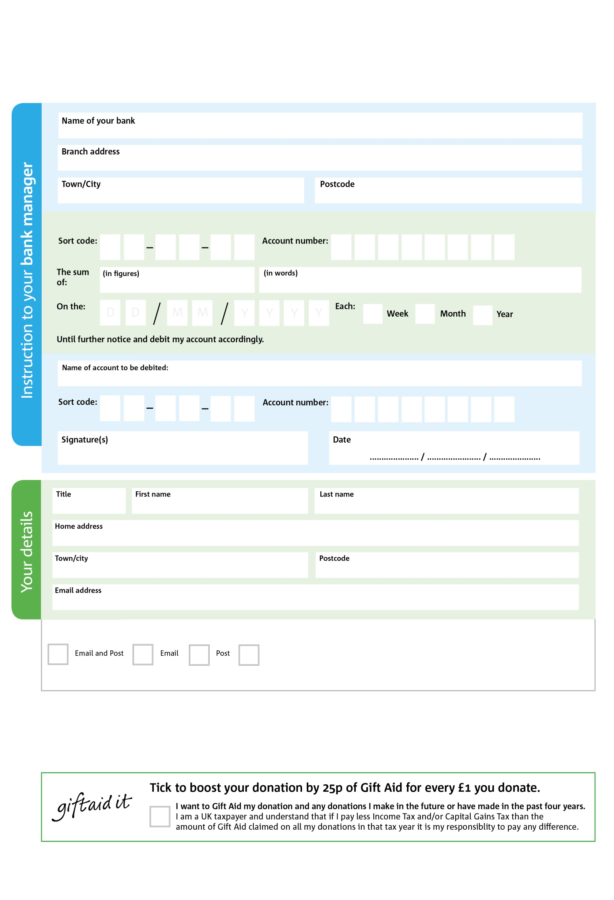

POSTAL ADDRESS: Wadebridge Foodbank & Storehouse, 4 Eddystone Road, Wadebridge, Cornwall. PL27 7AL

Reg. Charity No: 1166301 (England & Wales)

0X

V

**Standing Order Mandate**

**contact@wadebridgefoodbank.org**

3

V

2

V

2

V

3

V

6

V

6

V

1

V

**Please pass this form onto the foodbank, using the foodbank’s address at the bottom, who will save a copy for their records.   
They will then send it onto your named bank or building society.**

8

9

8

9

0

3

We would love to keep you up to date with information about Wadebridge Foodbank. Please tick your preference:

You can change your preferences any time by contacting us on 01208 815374 or emailing us at contact@wadebridgefoodbank.org

I do not wish to receive future communications from Wadebridge Foodbank

Please pay Wadebridge Foodbank

**Data protection**

*Wadebridge Foodbank is committed to protecting your privacy and will process your personal data in accordance with current Data Protection legislation. Wadebridge Foodbank collects information to keep in touch with you and supply you with information relating to our work. To unsubscribe from our newsletter, send a message to the email address above with the word unsubscribe in the subject line. A full data privacy statement for financial donors is available from the foodbank on request.*

You can change your preferences any time by contacting us on XXXXXXXXXXX or emailing us at XXXX@XXXXXXXXXX.foodbank.org.uk

I do not wish to receive future communications from XXXXXX Foodbank